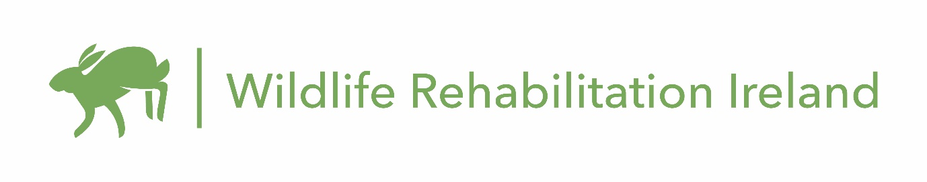
Job title: Wildlife Veterinary Nurse Intern
Reports to: Hospital Manager
Supervises: Wildlife interns and volunteers
Start Date: Immediate
WRI provides people a place to bring native wildlife struggling to survive with the goal of releasing healthy individuals back to nature. WRI’s Wildlife Hospital, the only dedicated wildlife hospital in Ireland, is currently offering a full-time internship for a wildlife veterinary nurse. Working alongside the Animal Manager, the veterinary nurse has responsibilities in all aspects of medical care for Ireland’s injured, ill, and orphaned wildlife. A full range of species are brought to the WRI Wildlife Hospital annually comprising mostly bird and mammal species, with some amphibians represented.
Position Summary:
The wildlife veterinary nurse is a member of the WRI Wildlife Hospital veterinary team, reporting directly to the Hospital Manager. The veterinary nurse is responsible for the daily medical care of wildlife patients, including critical care, anesthesia, examinations, wound care, physical therapy, necropsies, feeding plans, and species-specific husbandry, among other responsibilities. In conjunction with the Animal Manager, the veterinary nurse must be willing to patiently teach and direct staff, fellows, interns, volunteers, and possibly students. The veterinary nurse will be part of a growing medical team at WRI Wildlife Hospital.
Duties and Responsibilities:
The Wildlife Veterinary Nurse will
Efficiently and effectively assist in the medical care of wildlife patients including physical therapy, and other supportive or rehabilitative care needed
Perform euthanasia when deemed the best course of action for a specific wildlife patient
Enthusiastically and effectively train interns and volunteers as directed by the Hospital and Animal Managers
Ensure the wildlife hospital has the supplies and medications needed to efficiently and effectively carry out the work on a daily basis
Identify and suggest ways to improve both medical and rehabilitative care of patients as part of the broader hospital team. These duties ensure the highest standard of care is provided to our wild animal patients.

Other Responsibilities:
Assist in the creation and compliance of protocols and procedures.
Ensure adherence to local laws and safety rules.
Perform daily interactions via face-to-face, phone, or email with the public and colleagues at other centers including rehabilitators and veterinary staff.
Adhere to appropriate social distancing and other guidelines such as facemasks during pandemic.
Remain current on veterinary medicine as required for maintaining licensure, but also to ensure we are providing the highest-level care possible for patients.

Qualifications:
Registered Veterinary Nurse degree from accredited third level institution, with a minimum of two years of experience as a licensed nurse or rehabilitator in the care and treatment of wild animals.
Up-to-date tetanus and rabies vaccinations.
Perform common veterinary diagnostics including radiology and faecal examination
Triage and initiate appropriate treatments.
Flexibility to work varying schedules including work on weekends when needed.
Safe animal handling skills required, with wildlife handling knowledge preferred.
Experience and knowledge in the natural history and behaviour of native wildlife species is preferred.

General Competencies:
Attendance and Dependability - Consistently at work and on time. Follows instructions and responds to management direction.
Does not misrepresent self, the organisation, or use position or authority for personal gain.
Teamwork - Listens and responds constructively to others' views. Gives and welcomes feedback. Helps others when they need it. Shares expertise. Acknowledges others' effort and contribution. Puts success of team above own interests. Creates a positive work environment.

Rewards:
As the Wildlife Veterinarian Nurse intern you will receive full bed and board on site in our large apartment, meaning no travel expenses to and from the hospital.

To Apply:
Please submit a cover letter stating qualifications and interest, curriculum vitae, and three contacts for recommendations to office@wri.ie by 30th April, 2021. Put “Wildlife Veterinary Nurse” in the subject line.

